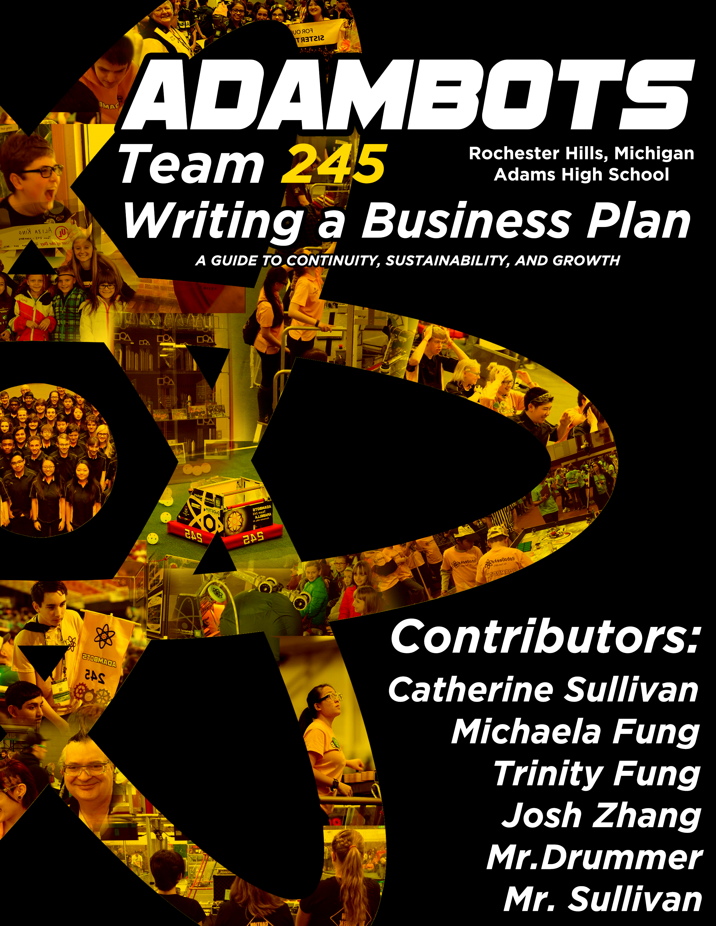

<https://lh5.googleusercontent.com/YX1JvPOQOuqaXkbOUPTVU6K_dsLfgjBdqRTkblMr6sINRILlhbNHibqDjM0v4g8qH1H26YYBmuMK1sbBv2mb=w1366-h588-rw>

## Table of Contents

About this Resource 2

Business Planning Introduction 3

1) Executive Summary 4

2) Team Information 5

3) Organizational Plan 6

4) Outreach and Mentoring Plan 8

5) Operational Plan 9

6) Marketing Plan 10

7) Financial Plan 12

8) Strategic Plan 13

Conclusion 17

## About this Resource

*Writing a Business Plan* was written to help the sustainability, continuity, and partnership of *FIRST* Robotics Competition teams. While we recognize that other models may be better-suited for some teams, we have been successful under this one. Feel free to use any information you find here. More resources can be found at:

**http://www.adambots.com/resources/resources-overview/**

If you have any questions, we would love to help you out. You can contact the team at:

**TheAdamBots@gmail.com**

|  |
| --- |
| Yellow boxes represent examples from the AdamBots 2018 Business Plan. |

## Business Planning Introduction

The business plan is how your team plans on functioning. It is documentation of how the team runs in an effort to sustain what it does with the ultimate goal of accomplishing the team’s mission statement. Many teams look at their business plan as “If the team were to completely restart with all-new members, they should be able to use this document to do everything we do today.” Every team should have a business plan, regardless of whether they have any intention of winning awards.

One way to structure your business plan is to use the Entrepreneurship Award submission outline (mission statement, team origin, organizational structure, relationships, deployment of resources, future plans, financial statement, and risk analysis). While the submission should run in tandem with the business plan, you have room in the plan to expand on what you submit for the award. Remember, everything needed to run your team should be mentioned in your business plan and then documented either there or somewhere else. If you’d like help with your Entrepreneurship Award submission, check out our guide at the link above.

This guide provides tips on using the AdamBots business planning structure. However, you can still use the guide for other structures, and we can offer help to any team looking to improve business planning.

## 1) Executive Summary

The executive summary briefly explains who your team is. Write it as if the reader had never heard of *FIRST* before and wanted to know what your team is all about. It has three major sections: **mission statement**, **core values**, and **team summary**.

The **mission statement** is what your team is trying to accomplish. Your team probably wasn’t started just to win matches. Maybe it’s STEM education, maybe it’s some level of community involvement, but there is a purpose behind your team. Ideally, it would be more important than competition performance, with competition as a vessel for achieving the mission. Take some time to write this. Though it might only be a sentence or two, it’s the most important section of your business plan. Everything you do should directly or indirectly support your mission.

|  |
| --- |
| AdamBots Mission Statement  “To provide an inspiring learning environment that fosters growth and appreciation of STEM and business knowledge, and to teach students skills vital to success in the real world through a strong relationship between students, mentors and sponsors.” |

Your **core values** are what the team considers important to keep at heart. In your attempt to accomplish your mission, you should not sacrifice your core values. Ensure that these are actually what your team values (both students and mentors), as they remain important to many decisions in day-to-day activity.

|  |
| --- |
| AdamBots Core Values   * Gracious Professionalism * Respect * Teamwork * Innovation and Creativity * Fun * 3Cs: Communication, Cooperation, Commitment |

The **team summary** should say a little about who the team is functionally. Consider location, partnerships, and impact. You may also want to add a brief team history to highlight both growth and challenges.

## 2) Team Information

This section should be the easiest to write. It provides readers with a basic quantitative and factual context for your team. We simply listed the following:

* Rookie Year
* Location
* School Affiliation
* Demographics (Number of students, gender makeup)
* Mentors (Total number, number of business/engineering, number with no children on the team)
* Sponsor list
* Website address

As an extension, we also included a list of benefits for those who dedicate their time and resources to our team (students, mentors, sponsor, school), and an in-depth explanation of our core values.

## 3) Organizational Plan

For sections 3-7, it can be a good idea to include a summary of the information in that section at the beginning once you finish the section. That way, people skimming your business plan can get the gist of your team without reading the whole thing.

This section is about how your team organizes its tasks. The sections within it are **team structure**, **human resources**, **location**, and **larger team functions**.

The **team structure** is how your team divides up the work. It largely depends on what your team is looking to accomplish and who needs to work together to accomplish that. However, teams should have a plan to fulfill each of following central roles:

* Team Manager: Responsible for all team functions, often delegating tasks.
* Financial Manager: Responsible for team accounting.
* Purchasing Manager: Responsible for team supplies.

and the following operational roles:

* Coach: Advises students on technical subjects.
* Technical Leader(s): Students and/or mentors responsible for robot completion.
* Non-Technical Leader(s): Students and/or mentors responsible for non-robot tasks.

To determine which roles need to exist, start by listing out all the tasks the team needs to complete. Lots of different tasks go into building a robot, and lots go into managing non-technical robot functions. It’s also important to consider the team functions that don’t relate to your mission statement but still need to get done. For example, have a person or group responsible for food and for hotel booking.

You may want to divide these roles across numerous people and groups, but ensure someone is accountable for each of them. While co-leaders are often helpful, if nobody is individually accountable for successes and failures, rate and quality of work can drop.

The **human resources** section documents how you develop your students and mentors. This includes:

* Recruitment
* Training and succession planning
* Team building
* Member expectations
* Safety

**Location** is simply where your team works. For many teams, this is a building’s workshop or computer lab, but some teams have many sites that they use.

**Larger team functions** are activities too large to assign to a specific group. In our business plan, our larger functions are the *FIRST* season, the OCCRA season, and the *FIRST* offseason.

## https://lh5.googleusercontent.com/Fwi8tsd2BMVdv34FuAOb_Xh9BNLQid9nXYAC5zlHaG46yoGhlPqzwCQ8ASC9n-E0vmlbcrNfh69O12MphDMbLitOR89i96vBzMHJ6okQOrCWNReJ1GNwYuDgdz5YQMFgnklndWdB

## 4) Outreach and Mentoring Plan

In this section, document your tasks that help others. Make sure to answer the questions, “What do you do?” “What impact do you have?” and “Why do you do it?” Ours is divided into **community outreach** and **mentoring and assisting other teams**.

**Community outreach** summarizes any projects you have to better your local community. In general, these should relate to your mission, but it’s never a bad thing to help those in need regardless.

**Mentoring and assisting other teams** summarizes how you develop a robotics community. If you have a strong relationship with another *FIRST* team, whether giving or receiving help, explain it here. Also list all of your feeder programs (teams and clubs for younger students that “feed” into yours) and what you do to support them.

This section could fit under your Operational Plan or Organizational Plan, but there’s two main reasons we give it its own section. First, the large number of activities means it would take up several pages regardless of the section, so it fits better alone. Second, two main audiences reading the business plan are *FIRST* judges and other interested teams. While the words in the business plan aren’t written with judges in mind, it makes the info they’re looking for more accessible.

|  |
| --- |
| Relay for Life           The Relay for Life is a walk to support the American Cancer Society. The AdamBots participate in the local Rochester Area Relay for Life every summer. The team raises money by selling luminaries. Luminaries are placed around a track in honor and memory of those who have died from cancer or who are currently battling it. Our team has been recognized by the American Cancer Society as the top team fundraiser in our area for the past two years, and we have raised more than $93,000 over the years. |

## 5) Operational Plan

This is how tasks are actually accomplished, from when they will be done to who is responsible for getting them done. It should expand on the structure you laid out in the Organizational Plan. The sections are **scheduling**, **communications**, and **project management**.

Start with the list of tasks you made in the Organizational Plan. Record this here, so when you check through your business plan to see if the team operated properly, you can see all the tasks and evaluate their success.

The **scheduling** section broadly covers when meetings are held. For example, a team might meet in the evenings each weekday during the build season to work on the robot, and have one weekly logistical meeting. You don’t need to write down your entire schedule, but make it clear that you typically meet during a set time range so people who aren’t familiar with the team know how you operate.

The **communications** section explains how you get information from one part of the team to another. Some teams have a clear-cut way of communicating, such as a team Slack or Discord group chat. Others might leave groups to find their own preferred method, which can be successful as long as they are held accountable by each other to stay in contact. It’s important that there is a defined way for any person on the team to contact any other person.

Our **project management** section is an expansion on communications. To handle the number of people and functions, we have two project management subteams who are accountable for their field, whether engineering or business. Your team might not need frequent management meetings to stay close-knit, but make sure you have some sort of documented way to keep the team as a whole accountable for each task. This often goes hand-in-hand with your Organizational Plan.

## 6) Marketing Plan

This section explains how you create and maintain relationships with groups and people outside of your team. Make sure you have a plan for each of these to ensure you don’t lose access to a key partner. Consider:

* Financial sponsors
* Assisting/mentoring sponsors
* Build space provider
* Potential students and mentors
* Other robotics teams

Start by recording how you keep in contact with the most important of these, so somebody who is running your team won’t miss them. From there, you can explain each of your methods of reaching out and keeping the relationship.

For each method you use, record what you do and who gets your message. These might include:

* Robot demonstrations
* Open house
* Newsletter
* Thank you letters
* Website
* Social media
* Branding

Specific key partner:

|  |
| --- |
| Rochester Adams High School Administration  We market ourselves to the administration and faculty to ensure their strong, continued support through formal meetings, casual conversations, and team demonstrations. We formally invite the principal and faculty to attend events hosted at home. We also extend invitations to administration and faculty to attend all of our local competitions. Through our involvement in the school board’s Career and Technical Education (CTE) Advisory Committee, we market the value of our team’s activity. In addition to CTE, one AdamBots parent is a member of the school board. |

Method:

|  |
| --- |
| Meet the AdamBots  Every year our team hosts an open house called “Meet the AdamBots.” This event has been a successful means for our team to inform and build relationships with partners, school administration, politicians, community leaders, parents and family members by introducing them to our team, our projects, facilities and how we operate.  The goals of “Meet the AdamBots” are to reach out to all our  partners, spark interest to gain new partners and spread the message of *FIRST*. A presentation explaining our team, our history, and the objective of the current year’s game is given. Also, those attending are broken up into small groups and led by student guides on a tour where they see our build room and meet students from our sub-teams who explain and present their sub-team’s function and projects. The tour also includes a demonstration of our robot for the current and past seasons. |

## 7) Financial Plan

This section explains how you will get and spend the money you need to run your team. It’s divided into two main sections: **sources of funds** and **uses of funds**.

For the **sources of funds** section, briefly explain how you raise money. To begin, list off your financial sponsors. Many teams have sponsorship tiers, where donating a certain amount of money leads to more benefits to the company. If your team uses this system, this is a good place to put that information. From there, you could have any number of sources of funds. Other typical ones include team fundraisers and member travel fees. Once you have each source logged, put it into a pie chart so it’s easy to understand where a majority of your money comes from.

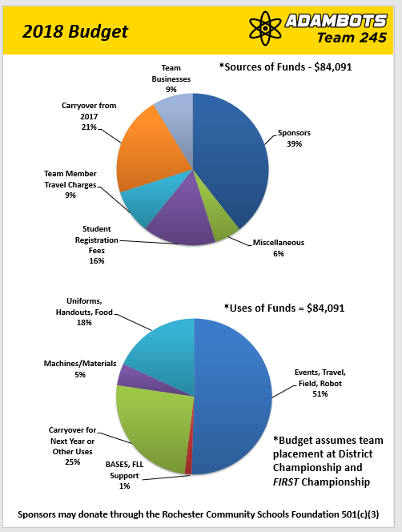For the **uses of funds** section, most of your expenses will have already been mentioned in another section, so you don’t need to explain each one. It’s enough just to consider the major expenses and put them in a pie chart.

Some of the uses of funds will require making projections. When you can, plan for the most expensive season possible, so you won’t be scrambling to raise money if you qualify for the Championship. Also, try to leave seed money for next year. 15% of your total budget left over is a good goal to shoot for.

## 8) Strategic Plan

This is the hardest section to write. It sets a framework for how your team will make long-term decisions. Because the framework should remain fairly consistent from year-to-year, make sure you give this section the time it needs to be done right. Once it’s done, revise it 1-2 times each year. Ours is divided into **team strategies**, **SWOT analysis**, **action plans**, and an additional section for **measuring success**.

The goal of the strategic plan is to make sure your team is accomplishing its mission statement to the best of its ability, with the understanding that the team cannot do this if it falls apart. To simplify this complicated problem, separate your mission statement into 3-5 key **team strategies**. Treat each of these like its own mini mission statement that needs to be accomplished for your team to be successful.

|  |
| --- |
| AdamBots Team Strategies   * Grow a model team * Learn and continuously improve by by building a successful robot * Develop strong team leadership * Develop excellent financing and partner relationships * Spread the message of *FIRST* |

Next, put your mission to the side for a moment and analyze how the team currently functions. To do this, create a **SWOT analysis** (strengths, weaknesses, opportunities, threats) with a list of 3-7 actionable items per category. The SWOT analysis is an expansion on a typical “what’s been good/bad” season recap to ensure all actionable items are considered.

Strengths include the major things your team does well. This would be the “what is good” category in a typical team analysis. For example, a team whose students show strong commitment might record commitment as a strength. Later, it will be useful to that team to understand that they can capitalize on their commitment and ask their students to work more.

Weaknesses include the major things your team does poorly. This would be the “what is bad” category in a typical team analysis. If your team rarely has a functioning robot by the first competition, or conflicts flare as build ends, that’s good to note.

Opportunities are anything that your team could better take advantage of. This category is included so your team can see things that you could act on but haven’t impacted the team yet. Take some time to brainstorm any existing or potential partnerships, resources available to teams, or anything else that could help you be a better team. The list could go on and on, so only include a shortened list in your business plan’s SWOT analysis.

Threats are things that could prevent you from maintaining your current level of operation. This category is included so your team can see things that could be a major problem in the future but haven’t significantly impacted the team yet. These can range from moderate challenges to guaranteed team collapse.

Below is a sample mini SWOT analysis. Rather than using the AdamBots analysis, it is a made-up team’s to provide a better example.

|  |  |
| --- | --- |
| **Strengths** | **Weaknesses** |
| * Lots of mentors * Feeder programs * Highly competitive robots | * Training younger students * Almost no money left over after each year * Conflicts between team leaders |
| **Opportunities** | **Threats** |
| * Asking mentors to ask their companies for sponsorships * Learning from strong nearby teams * Training programs at local university | • Loss of key mentors  • Loss of build space  • Loss of financial support |

After your SWOT analysis is done, the next step is **action plans**. This part should be planned with as much of the team as possible. For each key team strategy, brainstorm actions the team could take that would allow you to best accomplish that strategy. Take the items from your SWOT analysis into account.

For example, if the sample team has a strategy of “Prepare students for the real world,” they could note the strength of “lots of mentors” and create a system for mentors to share their real-world experience. Their weakness of “training younger students” could lead into stronger training programs. The opportunity of “learning from strong nearby teams” could be asking another team how their training works so the team can improve theirs. Threats often become risk mitigation plans, where something is done because it prevents emergencies later, rather than because it’s already causing problems. A separate key team strategy might have the risk-mitigating action plan of gaining at least one new sponsor each year.

Decide how much is possible for your team to handle and which ones are the most important. Once you have a shortened list, for each action plan, record who is responsible and when it should be completed. The deadline can either be a one-time date or repeated (e.g. annually). All that’s left to do is execute your plan.

|  |  |  |  |  |  |  |  |  |  |  |  |  |  |  |  |  |  |  |  |  |  |  |  |  |
| --- | --- | --- | --- | --- | --- | --- | --- | --- | --- | --- | --- | --- | --- | --- | --- | --- | --- | --- | --- | --- | --- | --- | --- | --- |
| |  |  |  | | --- | --- | --- | | **AdamBots Team Strategy: Develop Excellent Team Financing**  **and Partner Relationships** | | | | **Action Plan** | **Responsible** | **Estimated Completion** | | Improve planning and purchasing of special equipment, tools, computers and software | Team Leadership, Project Management | Annually by end of year | | Contact partners to determine internship opportunities for AdamBots students | Financial Manager | Annually by end of year | | Practice and improve team business, engineering and robot presentation skills with comprehensive meetings | Project Management | Annually by 1st competition | | Send a high quality electronic newsletter to update all partners including: sponsors, school administrators, community leaders, team members, parents and alumni | Marketing | Monthly or alternating months | | Develop at least one new method to spread the *FIRST* message with our partners, especially within our high school and school system | Marketing Team | Annually | | RISK MITIGATON: Gain at least one new partner every year | Financial Manager | Annually by end of year | |

To **measure success**, one feature you could add is Key Performance Indicators (KPIs). These are measurement systems to determine if your team is approaching success in completing your mission statement. They’re helpful when making decisions because they provide data to show what parts of the team need more work than others. KPIs become more valuable the longer you measure them because you can see the impact of previous actions and analyze trends.

Start by discussing what your team considers success. The idea is to be able to say “Regardless of awards, the team was successful/not successful this year because...” Take your mission statement, key team strategies, and core values into account. A good KPI is measurable, actionable, and truly “key” to the team’s performance.

|  |  |  |  |  |  |  |  |  |  |  |  |  |
| --- | --- | --- | --- | --- | --- | --- | --- | --- | --- | --- | --- | --- |
| AdamBots Key Performance Indicators   |  |  | | --- | --- | | Indicator | Measurement Method | | Competition Performance | AdamBots Performance Rating (derived from District Ranking System) | | Student STEM Interest | Number of students in STEM clubs at school | | Student knowledge | Monthly subject area proficiency surveys | | Alumni STEAM Interest | What percent of graduates move on to STEAM fields? | | Team Environment and Core Values | Monthly student surveys covering respect, teamwork, communication, and fun | |

## https://lh3.googleusercontent.com/6HVN-B2obP6NAGHqvQj5Aqh2VIaDCnapFLGLwIDGh_X4eI2DdGjcCAI9zb3LSneCpNtuPah0-B9EQVz_HOZBBiP0h0RlH_BJRjhqToj5FkD4GUGVXGj_jK3bBMkQnWH6qhkxkLdo

## Conclusion

As your team grows, it’s easy to get wrapped up in the awards and the robots on the field. While these are definitely exciting, just make sure that you remember what your team is about: the mission. If you forgo your mission for a trophy, you’ll miss out on the opportunity *FIRST* presents to make a real difference.

At this point, you should have a functioning business plan to keep your team functioning how it is today, while planning for the future. Don’t forget to update it at least once a year so the information stays current. If you need help in the process, feel free to contact the AdamBots at the email below. Good luck with your team!

**TheAdamBots@gmail.com**

**www.AdamBots.com**

Special thanks to our editors at:

Team 862 Lightning Robotics

Team 1807 Redbird Robotics

Team 4384 Benzene Bots

Team 4946 Alpha Dogs

Team 6814 Eclipse

FullCircle Rookie Resources

