# 

Table of Contents

1.0 Executive Summary 4

2.0 Team Information 7

​2.1 Basic Team Facts 7

2.2 Member Benefits – Students, Mentors, School, and Sponsors 8

2.3 AdamBots Core Values 9

3.0 Organizational Plan 10

3.1 Team Structure 10

3.2 Human Resources 11

3.3 Organization of Operational Functions 13

4.0 Operational Plan 15

4.1 Tasks 15

4.2 Scheduling 16

4.3 Communication 16

4.4 Project Management 16

5.0​ ​Outreach and Mentoring Plan 17

5.1 Community Outreach 17

5.2 *FIRST* ​​Support 18

5.3 STEM Inspiration 20

6.0​ ​Marketing Plan 22

6.1 Target Audience 22

6.2 Marketing Mediums 23

7.0 Financial Plan 25

7.1 Partners 25

7.2 Member Contribution 25

7.3 Parking Lot Business 26

7.4 2022 Financial Graphic 27

7.5 Financial Contingency Plan 28

8.0 Strategic Plan 29

8.1 Strategic Planning Process 29

8.2 Team Strategies 29

8.3 SWOT Analysis 29

8.4 Action Plans and Risk Mitigation 31

9.0 Measuring Success 34

9.1 Key Performance Indicators 34

9.2 Implementation 35

# 1.0 Executive Summary

**Team Mission Statement**

“To provide an inspiring learning environment that fosters growth and appreciation of STEM and business knowledge, and to teach students skills vital to success in the real world through a strong relationship between student, mentors, and sponsors.”

At the nucleus of our mission, student and mentor team members collaborate to inspire interest, knowledge and application of STEM, business, and leadership skills. FIRST values such as Gracious Professionalism™ and Coopertition™ serve to bond our members-- students and mentors alike-- and provide a focus for all that we do. Orbiting the nucleus are our Core Values which further energize us to sustainable team success and contribute to the goal of spreading the word of FIRST.

**AdamBots Core Values**

**Why a Business Plan?**

Our Business Plan has been created to document the team’s approach to achieving our mission and to define, manage, and achieve objectives in a sustainable manner. The AdamBots radiate our positive charge in a way that attracts, enthuses, and empowers future team members as well as other FIRST teams both in our area and around the world. This business plan helps us develop and demonstrate our vital planning and business skills so we can continue our self-sustaining program.

**Team Summary**

Based at Rochester Adams High School in Rochester Hills, Michigan, the AdamBots began in 1999 with a small team of ten. We have grown steadily and today have 58 students and 25 mentors. We build our robots, and run our business teams, at Adams using a connected set of rooms including the build room, CAD room, electrical room, our dedicated practice field, storage room, and two classrooms. The AdamBots are heavily involved in the local and global STEM communities, including supporting FIRST at all levels. We have many sponsors, including corporate, government and friends and family that together fund almost half of our team expenses. Our largest sponsor is General Motors. Each fall we raise over $7,000 through our successful parking lot business. Community outreach is integral to our team culture, and the AdamBots provide over 2,000 hours of community service and outreach each year. Our team has been a top team fundraiser for the local American Cancer Society’s Relay for Life raising more than $110,000 over the years. Our community service also resulted in our city mayor awarding us the Community First Award, for making “a notable effort to improve the quality of life for those around” us.

|  |
| --- |
| Business Plan Roadmap |
| **1.0 Executive Summary**  Summary of team mission, what is important to us and roadmap of our Business Plan document |
| **2.0 Team Information**  Gives team demographics, benefits to team members, sponsors, and school, and Core Values |
| **3.0 Organizational Plan**  Explains team structure, training, expectations of members, safety, location, and off-season events |
| **4.0 Operational Plan**  Details major ​FIRST​ season tasks and how we manage our work |
| **5.0 Outreach and Mentoring Plan**  Explains how we spread ​FIRST​ by mentoring teams and give back through community service |
| **6.0 Marketing Plan**  Explains how we use our brand to enhance partnerships with others |
| **7.0 Financial Plan**  Details how we manage our team finances for sustainability |
| **8.0 Strategic Plan**  A 1–5-year plan which defines our goals and actions to get there; also addresses risk management |
| **9.0 Measuring Success**  Outlines efforts to identify how the team succeeds and where the team can improve |

# 2.0 Team Information

## ​2.1 Basic Team Facts

|  |  |
| --- | --- |
| **Rookie Year** | 1999 |
| **Location** | Rochester Adams High School, Rochester Hills, Michigan |
| **School Affiliation** | Rochester Adams High School |

|  |  |
| --- | --- |
| **Team Demographics** | 58 Students (up from 10 during Rookie year)   * 17 girls and 41 boys * 11 Seniors, 8 Juniors, 7 Sophomores, 31 Freshmen, 1 8th grader |
| **Mentors** | 1. Mentors (up from 3 during Rookie year)   19 of our mentors have no children on the team  We draw mentors from current and retired teachers, alumni, and past and present team parents. |
| **Sponsors and Partners** | General Motors (grants/mentors – Mr. Rylko-6 yrs., Mr. Yin-1 yr., Mr. Drummer retired-23 yrs.)  APTIV Foundation (grants/mentors – Mr. Price–2 yrs., Mr. Koravadi–1 yrs., Mrs. Lopez-vol.)  R&G Drummer (grants/mentors – Mrs and Mr. Drummer-23 yrs.)  DTE Energy (grants/mentor – Mr. Bueltel–7 yrs.)  FCA Foundation (grants/mentors – Mr. Merlo–12 yrs., Mr. Radabaugh–2 yrs.)  State of Michigan Robotics Grant (grants)  Thyssenkrupp (grants/mentor - Mr. Sochanski–12 yrs.)  Rochester Advanced Dentistry (parking lot use – funds)  Rochester Community Schools (administrative support)  Rochester Adams High School (building use and administrative support)  Friends and Family (team fees and donations) |
| **Website** | AdamBots.com |

### 

## 2.2 Member Benefits – Students, Mentors, School, and Sponsors

**For Students:**

* Learn how to plan and build a working robot
* Develop confidence, communication, and leadership skills
* Have fun
* Be part of a community and work as a team
* Help others through community outreach
* Gain opportunities to earn scholarships and obtain internships
* Get a head start in studying a STEM related field such as engineering etc.
* Develop multi-tasking and time-management skills
* Work with and learn from adult mentors who have professional experience in the areas of science, technology, engineering, math, and business

**For Mentors:**

* Share knowledge and experience with students to help them accomplish their tasks, in both engineering and business areas
* Have fun
* Be part of a community and work as a team
* Help others through community outreach
* Help give the students a “real life” learning experience they cannot get in the regular classroom

**For School:**

* Support an outstanding student development program
* Support STEM and business interests in students
* Increase name recognition as a school that helps develop outstanding students
* Gain insight of professionals outside of academia to help set curriculum
* Help support students through scholarship opportunities

**For Sponsors:**

* An opportunity to market their company
* Reach out to the community in a positive way
* Develop future employees
* Help inspire students to enter STEM and business fields
* Provides opportunity to be good corporate citizen

## 2.3 AdamBots Core Values

Students and mentors worked together to define Core Values which we believe are key to our success, sustainability and help us to be a role model team.



AdamBots

245

Gracious Professionalism

We will do the right thing with integrity. We will set positive examples for others to follow. We will compete on an even playing field and will help our allies and opponents be their best. We will also be on our best behavior whenever we are participating on the team; at the school, at competitions, at robotic demonstrations, and at community outreach events. *“Gracious professionals learn and compete like crazy, but treat one another with respect and kindness in the process…In the long run; Gracious Professionalism is part of pursuing a meaningful life. One can add to society and enjoy the satisfaction of knowing one has acted with integrity and sensitivity.”* – Woodie Flowers

3Cs: Commitment, Cooperation,  
and Communication

We believe that all members of the team should demonstrate commitment to the team values and mission, cooperation with all team members, and a continuous effort to communicate so the team can meet the mission of FIRST and our team. We believe that the team leadership should set the example for all team members to follow and help keep us on track with the 3C values.

Respect

We accept each other and the unique talents and experiences we bring to the team. We behave in a spirit of honoring each other as members of the family. We will listen to the opinions and observations of others. We will give respect in order to receive respect.

Fun

We believe that being a member of the robotics team should be a fun and enjoyable experience for all members. We believe that school work, robotics team responsibilities, and life should be integrated in a way that being a member of the team is a rich and rewarding experience.

Teamwork

Each member has a role to play on the team. Our best solutions come from when we work together with students, mentors, sponsors, and school administration. Effective teamwork demands strong respect, relationships, and communication.

Innovation & Creativity

We appreciate new ideas and imaginative ways to solve problems. We embrace trying new technology when appropriate. We strive to develop creative solutions and put them into action.

# 3.0 Organizational Plan

## 3.1 Team Structure

Our team is organized into nine engineering sub-teams and six business sub-teams, each with at least one student leader and one mentor. The team also has a Project Management sub-team, which oversees goals and deadlines for the robot. Several mentors fulfill the roles of Team Manager, Financial Manager, and Purchasing Manager. These roles supervise team administration, travel, finances, and purchases. Prior to the build season, students fill out forms ranking their top choices and nominating themselves for leadership positions. Mentors interview and select student leaders and place students on sub-teams based on their interests. For this past season, due to the COVID impact, we did not follow the normal process and students were selected based on self-nominations.



## 3.2 Human Resources

**Recruitment**

At the beginning of each school year, we start our recruiting process by giving the time and place of our first meeting on posters we hang up around our school to promote the robotics team. Many students also join as a continuation of our feeder programs. At the first meeting, we give an overview of our team and what the robotics season entails. Students can then decide if they want to join. We also recruit mentors during our Team Startup Meeting held in the first week of December. This is a meeting that both students and parents attend to receive detailed information on travel, competitions, fees, and more. At the end of this meeting, we encourage any parents who might be interested in becoming a mentor to sign up. Later in the year, they will attend a training session before *FIRST*​ season begins.

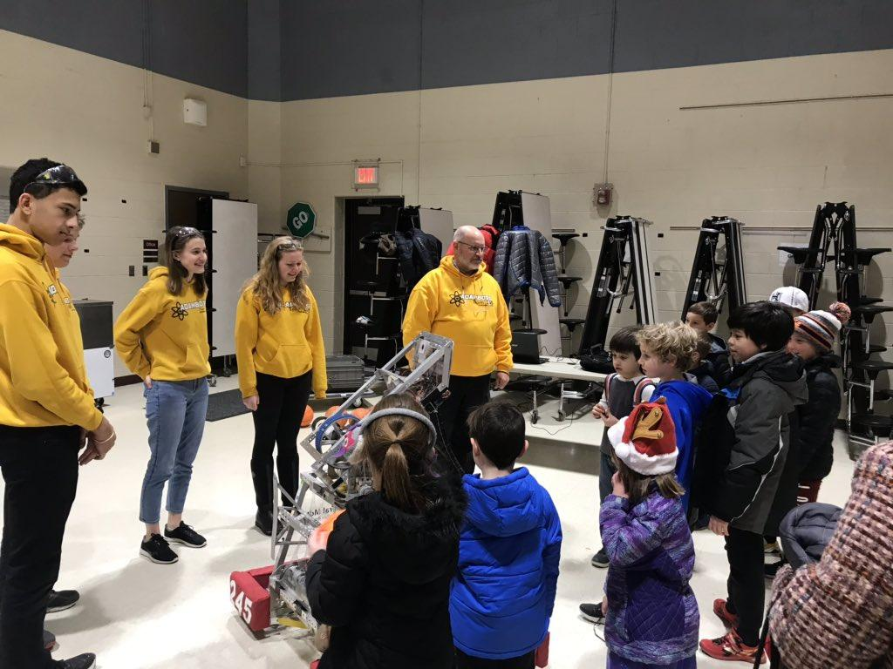

**Training**

A few years ago, the AdamBots began a new program called Project Hephaestus for training incoming students. With guidance from mentors and veteran students, incoming AdamBots created a robot from scratch to demonstrate in the Rochester Hometown Christmas Parade. Through this activity, students began developing relationships with mentors and veteran students earlier at the same time as gaining more hands-on experience working as a team toward creating a robot. Through this program, new students will enter the *FIRST*​ season with a knowledge of tools and safety as well as a taste of how the team is structured. This year we conducted the training virtually due to COVID impact on in-person attendance as school.

**Skills Approach to Sub-teams**

In addition to each sub-team’s contribution to the overall team, each sub-team is also defined by the specific real-world skills it teaches its students. Regular measurements ensure the team is aware of the threat of turnover in the case of only older students having high levels of experience. This “Skills Approach to Sub-teams'' boosts awareness of threats as well as ensures that the mission of the team is being accomplished within each sub-team. Each year, we measure the skills relevant to each sub-team through a self-evaluation given to the whole team.

**Attendance, Participation and Behavior Expectations**

It is important that students are on time to all events, matches and meetings. If a student is unable to attend, they should inform a mentor or student leader of their absence in advance. It is also important that all students regularly attend their own sub-team meetings so that they can not only stay current with the team’s progress but also to partake in it. Grades are of utmost importance to our team, the average GPA for the team is above 3.8. For a student to remain on the team, he or she must have passing grades in all classes because we do not want any member’s participation in the robotics team to become the cause of failure in their schoolwork. Students are also expected to participate in five community outreach activities throughout the year. Opportunities to sign up and participate are available regularly.

In addition, students are expected to exhibit Gracious Professionalism® at competitions not only for our team, but for other teams as well. We try our best to help other teams whenever any technical or operational issues occur on their side, although we are all competitors. Students are also encouraged to focus on the competition and avoid playing on an electronic device or other forms of entertainment. Team members must always strive to work together peacefully and cooperatively, remembering to be gracious in winning and losing. Other member expectations can be found in the Student Contract.

**Safety**

Safety of team members is critical. Students and mentors working with the robot at school or in the pit must wear safety glasses. Safety topics are covered in our fall training, and the use of power tools is supervised by experienced mentors. At the start of each competition day, a mentor conducts a safety talk with the entire team at the venue to ensure all know what to do in an emergency. More information can be found in our Safety Manual.

**EDGE Teaching Method**

Our team uses the EDGE teaching method, an effective four step teaching approach borrowed from Boy Scouts of America, to teach team members new skills and concepts. This approach is used consistently by mentors and students. The EDGE teaching method is similarly used to teach a wide variety of skills and concepts related to the AdamBots work, including any Engineering or Business sub-team task. For example, the method could also be used to show someone how to use a camera, update the website, or create items for the Business Plan.

* **Explain** – The trainer explains how something is done.​
* **Demonstrate** – After the trainer explains, the trainer demonstrates while explaining again.
* **Guide** – The learner tries the skill while the trainer guides him or her through it.​
* **Enable** – The learner works on his or her own under the watchful eye of the trainer. The​ trainer’s role in this step is to remove any obstacles to success, which enables the learner to succeed.

## 3.3 Organization of Operational Functions

***FIRST* ​Robotics Competition (FRC)**

The ​FIRST ​Robotics Competition runs from January to April, with approximately 4,000 teams participating globally. Teams compete in districts and regionals to earn a spot at the ​FIRST Championship. FRC stresses STEM inspiration by building relationships between students and mentors.

The ​FIRST​ Robotics Competition is the main season for the AdamBots. All students and mentors participate in FRC and the organization is as it appears in the chart. By participating in FRC, we inspire and educate our students in preparation for high-level competition.

**Oakland County Competitive Robotics Association (OCCRA)**

The Oakland County Competitive Robotics Association runs from October to November, with approximately 15 teams participating across the county. All teams participate in four ranking tournaments followed by the County Championship. OCCRA stresses growth of STEM and leadership skills by restricting mentor involvement to concept and safety and by disallowing the use of heavy machinery.

Our OCCRA team is made up of about 10 veteran students who have the skill set to build a robot without mentor assistance. Relatively few mentors participate in our OCCRA team, but we maintain the roles of Coach and OCCRA Team Manager. By participating in OCCRA, our leaders develop their skills and have a lot of fun.

***FIRST*​ Offseason**

Following the ​*FIRST*​ Championship, teams can sign up for additional independent events. The AdamBots compete in 2-4 offseason events each year. By participating in offseason events, we can train future drive team members. Our potential offseason events include:

* **Michigan Advanced Robotics Competition (MARC I & II)** ​– events where our students can practice and have fun
* **Indiana Robotics Invitational (IRI)** ​– July event in Indianapolis and one of the most competitive robotics events in the world. We’ve proudly been invited each year we’ve applied but one.
* **Kettering Kickoff**​ – September event in Flint where our students can practice and have fun in the leadup to the ​*FIRST* ​season
* **Bloomfield Girls Robotics Competition (BGRC)**​ – November event in Bloomfield Hills. This all-girls event allows our female students to get additional opportunities to drive and fix the robot

# 4.0 Operational Plan

## 4.1 Tasks

During the ​*FIRST*​ season, we are tasked to complete a new robot each year within a seven-week time frame. Our team also completes many other important tasks. Below are the tasks we work to achieve each year as a ​*FIRST*​ team. 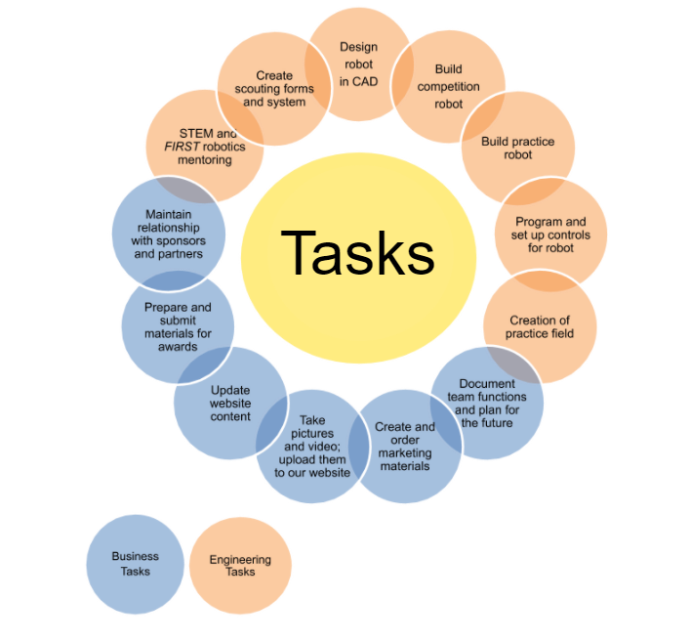

## 4.2 Scheduling

Each Wednesday after school, we conduct meetings that are attended by all student team members. We also meet at the beginning of the *FIRST*​ season, on the day after the game is announced, to conduct an initial strategy development session and begin the robot design process. Each Friday or Saturday engineering sub-team leaders meet to discuss deadlines and projects that involve multiple sub-teams. Each of our sub-teams meet at staggered times throughout the work week to ensure that there are not too many people in the robot build area. Sub-teams decide what schedule works best for both the students and mentors.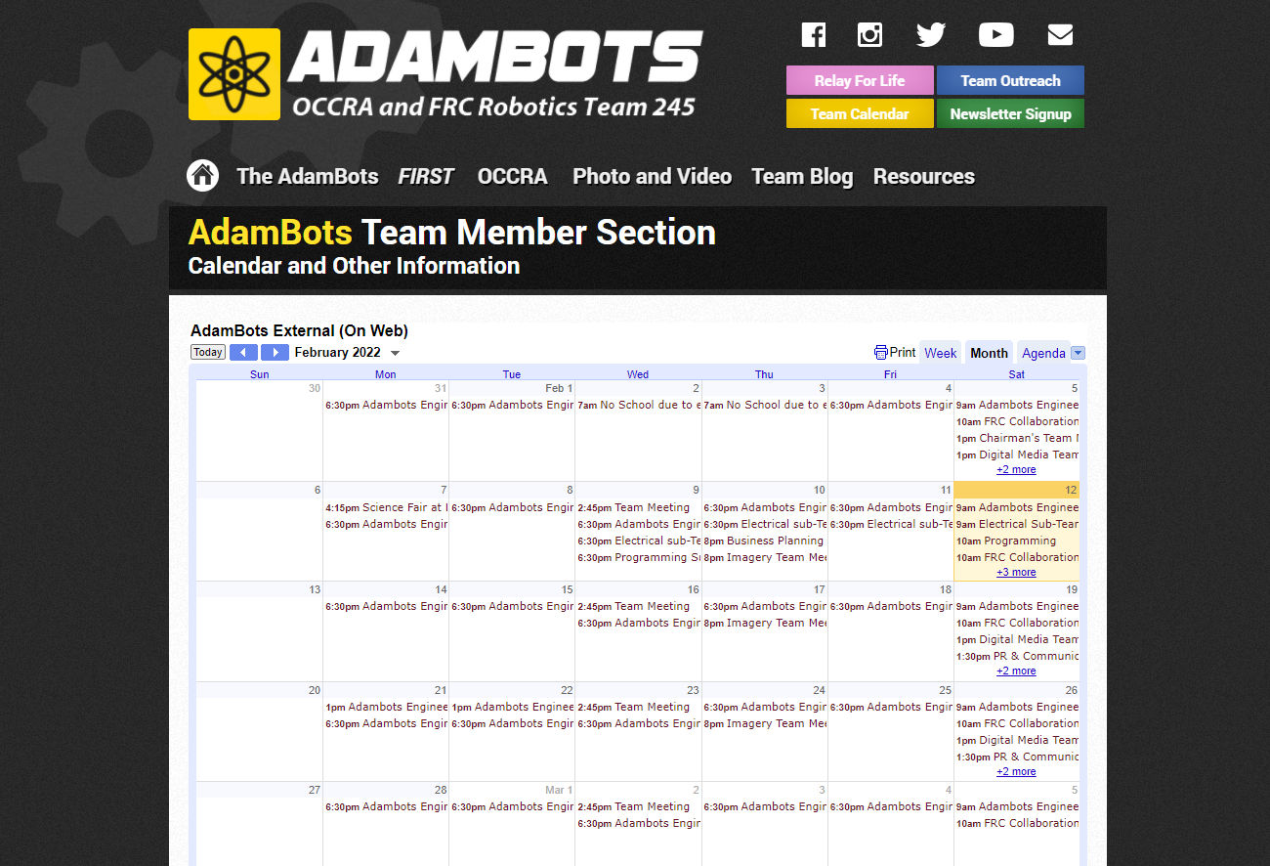

## 4.3 Communication

Communication within the team is accomplished with team meetings, sub-team meetings, emails, group chats, leader-to-member communication and the website. While traveling, we meet nightly to discuss plans for the next day. Our Team Manager sends emails to all team members and/or parents regarding events that involve the whole team. Student and mentor sub-team leaders send emails or text messages to communicate with sub-team members. On our website, www.AdamBots.com, we maintain a calendar for use within our team.

## 4.4 Project Management

Good project management is vital to our continued success during the *FIRST*​ ​ build season. Our team utilizes a Project Management Team to help keep our team on task and on schedule. The Project Management Team conducts weekly meetings with sub-team leaders to review progress, manage resources and resolve problems and a status review for the entire team every Saturday afternoon.

Engineering sub-team student leaders and mentors participate in a design review meeting every Monday evening that is led by the Project Management Team. During these meetings, each Engineering sub-team presents their design using CAD drawings. This review identifies design issues, coordinates interfaces between sub-teams and makes the robot build status visible to all involved. Issues are recorded on an action item list for follow-up after the meeting. The design process is debriefed to the whole team each Saturday. Our design process is documented in our Engineering Notebook. We adapted this process this past year due to COVID impacts on in-person meetings. We continued to manage the process to ensure we had a reliable, working robot that will meet our design objectives by the first competition.

# 5.0​ ​Outreach and Mentoring Plan

## 5.1 Community Outreach

The AdamBots choose to do many community outreach events to give back to our community, to spread awareness of ​*FIRST*​, and to emphasize the importance of social responsibility to team members. We provide over about 778 hours of total community outreach each year and are always looking for more opportunities to get involved in the community!

**Relay for Life**

The Relay for Life is a fundraiser walk to support the American Cancer Society. The AdamBots raise money for this event by selling luminaries every summer. We also wear pink shirts and provide pink ducks for fundraising at certain District events. Luminaries are placed around a track in honor and memory of those who have died from cancer or who are currently battling it. Our team has been recognized by the American Cancer Society as a top team fundraiser in our area for the past several years, however due to the global pandemic and its effects we were not able to participate in donations the past two years, we plan to jump back in this coming year and are signed up for an event in June. We have raised money for this fundraiser since we began participating in 2005.

**Hunger Walk**

The Hunger Walk is a local charity walk created by the AdamBots to support the Rochester Area

Neighborhood House and benefit those in our community who are in need. This year, we raised over $882. This event takes place in the fall, and participants include members of the AdamBots, Cyber Cats, and FEDS teams as part of Rochester United, as well as children from elementary and middle school teams we mentor and friends and family.

**Rochester Hometown Christmas Parade**

The AdamBots, along with other local ​FIRST​ teams, march in the Christmas Parade each December. It is a way to advertise our team along with the ​FIRST​ community, in the hopes of encouraging more people to join or recognize ​FIRST​. This year, we demonstrated the robot built by the rookie students in Project Hephaestus. A few students from each team walk next to these, carrying signs and posters for ​FIRST​. The parade was canceled at the last minute this past year, but we look forward to doing it in 2022.

**Halloween Hoot**

The Halloween Hoot takes place at the Dinosaur Hill Nature Preserve in the Rochester community every year in October. It is completely run by the community. Children carve pumpkins, teens act out Halloween skits, and members of the Rochester Hills Women’s Club provide cider and doughnuts. Since 2002, the AdamBots have cleaned up after the last night of the Halloween Hoot. We take down the decorations and pick up after everyone is gone from the trails.

**Books for Girls of the Crescent**

Two AdamBots students started the Girls of the Crescent, a non-profit, to donate books with strong Muslim women characters to schools and libraries. The AdamBots aid their initiative by purchasing books to add to their donations and fundraising for them with our scavenger hunt at the local outdoor Mall.

**Leader Dogs for the Blind Incubators**

The Leader Dogs for the Blind organization asked the AdamBots to help repair two coolers with heating elements, built by Oakland University, as incubators to transport newly born puppies, mostly delivered from a C-section. The electrical team is working on the repairs, which should be finished by the end of the school year, after the robotics season.

**Other/Past Service Projects**

This year, we collected and donated socks. Each winter, the AdamBots donate toys to the Rainbow Connection and/or to Toys for Tots. We’ve also baked cookies and delivered them to the fire department and senior living centers in our community. We collect coats for the needy and provide food donations to the local food bank. We also write Christmas cards for the Older Persons Center in our community. For many years, we cleaned up after the Make a Wish duck races in downtown Rochester.

## 5.2 *FIRST* ​​Support

**Rookie Team Mentorship**

In 2010, General Motors, one of our partners, asked for experienced *FIRST*​ teams to help rookie teams in Mexico. The AdamBots gladly chose to assist Team 3478, LamBot, from San Luis Potosi, Mexico.

Several LamBot mentors flew to Michigan and met with the AdamBots to discuss team structure and organization and the *FIRST*​ season. We attended regionals in Texas for two years to get to work more with them. The LamBots won the Rookie All-Star Award at the 2011 *FIRST* ​Championship. Since then, they’ve won the Regional Chairman’s Award three times, and the Engineering Inspiration Award at the *FIRST* Championship twice.

General Motors asked us to mentor a local Detroit team, 3096 Village Bulldogs. They were a rookie team and faced significant challenges in getting needed support from their school. We continue to mentor them and collaborate with them. In helping this team, we share our designs, offer feedback, and use many of the same methods used when first helping the LamBots.

In 2014, the AdamBots successfully started Team 5436, the Cyber Cats. Students from the local Stoney Creek High School previously came to our team, but we helped them to form their own at their school. After a successful rookie season, the Cyber Cats have expanded their team and acquired a workspace of their own. They’ve won numerous awards and qualified for the *FIRST*​ ​ Championship the past three years.

***FIRST*​ Season Video Calls**

Each Saturday during the *FIRST*​ ​ season, we host a video call with several other teams. Beginning with the LamBots alone, the call now includes ten other teams invited from across Michigan and Mexico (201, 245, 2224, 3096, 3478, 4735, 5213, 5436, 6121, 6832). Together we discuss strategy, robot design, team organization, outreach, business planning, Chairman's award work and any other topics requiring focus. We make plans to attend competitions with each of these teams when possible.

***FIRST ​*Tech Challenge (FTC) Event Hosting**

In 2019, the AdamBots hosted and ran Michigan’s first-ever FTC League Meet. We cooperated with FRC Teams 201 and 5436 to set up before and clean up after the event as part of Rochester United Robotics. Our team also provided volunteers for queueing and other event functions.

This year, we expanded our FTC support to host a qualifier. We again worked with the other Rochester United teams to draw volunteers for setup and cleanup as well as queueing, field reset, and judge assistance.

By running these events, we hope to develop the infrastructure of *FIRST*​ in Michigan to support the growth of FTC.

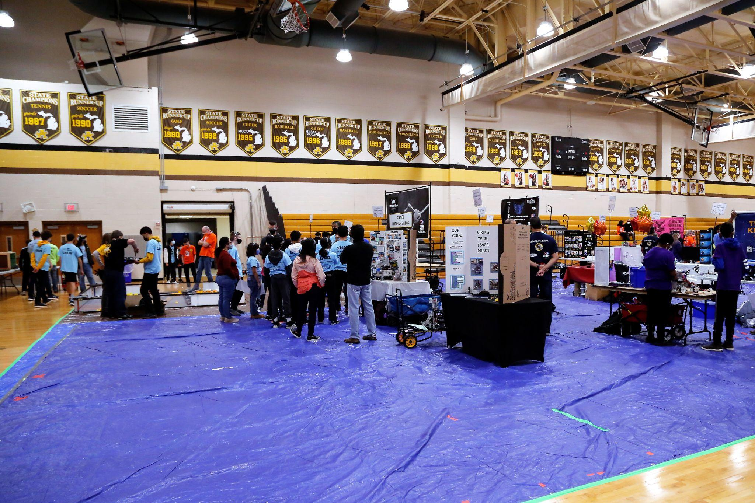

**FTC Mentoring**

In 2011, the AdamBots started and mentored an FTC team at our feeder school, Van Hoosen Middle School. Our team mentored both the engineering and business areas of the rookie team. After a brief period of absence, we helped restart that team in 2019.

***FIRST* ​Lego League Explore (FLE) and FIRST ​​Lego League Challenge (FLC) First Tech Challenge (FTC) Challenge**

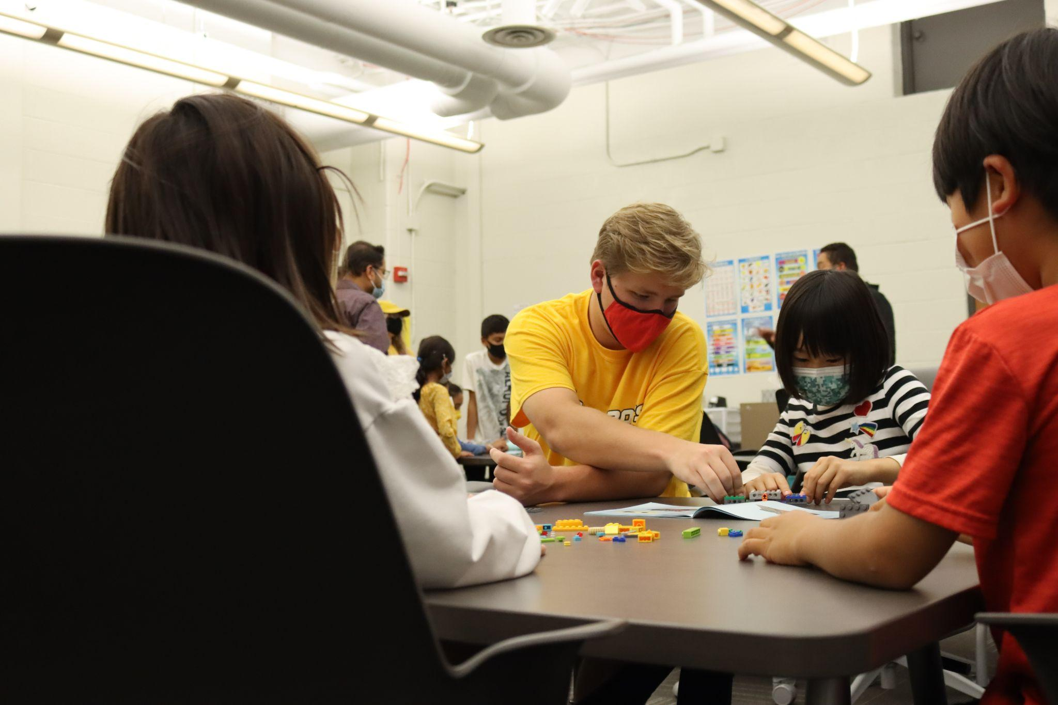

The AdamBots have supported FLE, FLC, FTC teams throughout nearly our entire history. This year we are mentoring 22 teams. We also started and continue to mentor 14 FLE, 6 FLC, and 2 FTC teams this year. The AdamBots fund all the FIRST​ teams. We meet with each team at least once per week, guiding students to appreciate STEM fields of education and the values of ​FIRST​.

***FIRST* ​Community Support**

At each local ​*FIRST*​ competition, we provide five to six volunteers to assist, including both mentor and student volunteers. We support not only ​*FIRST*​ season events, but also off-season events such as IRI, MARC and Kettering Kick-off. Volunteers help set up the competition field, administrate the pit area, queue teams, distribute safety glasses, and even coordinate other volunteers. Our volunteering is one way our team gives back to support the success of the ​*FIRST*​ community.

***LGBTQ+ of FIRST* ​Community Support**

The AdamBots are a Bronze Partner of the LGBTQ+ of FIRST and are moving to become a Silver Partner. This is a student run organization that seeks to create a safe and educated space for LGBTQ+ students, mentors, and volunteers of FIRST Robotics. We display a poster at our events and have students hand out brochures and business cards to encourage and support those in the community.

## 5.3 STEM Inspiration

**Robot Demonstrations**

We display our robots at different events, including elementary school assemblies, science fairs, partner locations, In the past, we also gave demonstrations to Girl and Boy Scout functions and library demos. For example, this year, students demonstrated the robot at the Long Meadow Elementary Science Fair. Robot demonstrations allow us to inspire students to have an interest in STEM education, spread awareness of ​*FIRST*​ and give partners a first-hand look at the benefits of our partnerships.

**Ambassador Program**

Several years ago students on the AdamBots started the Ambassador Program. We have many students who travel to foreign countries for vacations with family. These students take EV3 or other robotic kits and visit with children in the countries to inspire them to get involved in STEM. Just this year a student went to India and met with a class for an hour to encourage them to learn about science and technology. We’ve had Ambassadors go to Australia, England, Haiti, Mexico, India, and Japan.

**Hosting Girls STEM events**

The AdamBots have hosted many STEM events for young women in our community. These include things like: Girls who Code to teach basic programming skills at our local library and at our high school.

# 6.0​ ​Marketing Plan

## 6.1 Target Audience

**Rochester Adams High School Administration**

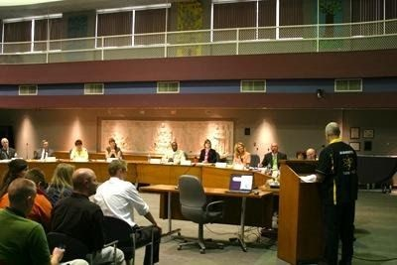

We market ourselves to the administration and faculty to ensure their strong, continued support through formal meetings, casual conversations, and team demonstrations. We formally invite the principal staff to attend events hosted at home. We also extend invitations to administration and faculty to attend all our local competitions. Through our involvement in the school board’s Career and Technical Education (CTE) Advisory Committee, we market the value of our team’s activity. In addition to CTE, one AdamBots alumni parent is a member of the school board.

**Partners (Sponsors)**

Sponsors provide the largest financial support, as well as many of our mentors and miscellaneous donations to the team. We target current and potential partners through marketing and direct communication to ensure their continued support and to gain new partners. Specific students and/or mentors are assigned to keep partners up to date, and we have visited partners to thank them for their assistance.

**Potential Team Members (Students and Mentors)**

We market to and strive to recruit team members, both students and mentors, because our people are the most important component of our team. We use in-school and online marketing to get the word of our team out to students and to invite them to apply to join the team at the beginning of the year. We demonstrate our robots at school whenever possible, including at a pep assembly this year. One way we showcase our team in the school is by wearing our spirit wear in class before competitions. We also encourage teachers and parents to mentor the team. The best way we can reach potential team members is through our various outreach and mentoring programs. There, we can encourage interest in STEM, FIRST​​, and the AdamBots.

**Rochester United Robotics**

The AdamBots also have partnered up with two other robotics teams to make a bigger positive impact on our local community. Along with the FEDS, FRC Team 201, and the Cyber Cats, FRC Team 5436, we do a variety of community outreach activities including the annual Christmas parade and the Hunger Walk. To maintain relations, periodic meetings with lead mentors from each team are held to discuss activities.

## 6.2 Marketing Mediums

**Robot Demonstrations / Speaking Events**

We regularly participate in a wide variety of events, where we demonstrate our robot and speak to attendees about FIRST​ and the AdamBots. Events have included elementary school science fairs and assemblies, Boy Scout and Girl Scout meetings, high school pep assemblies, demonstrations at freshman parent orientation, meetings with high school principals, presentations to the RCS School Board and demonstrations at the Rochester Hills Public Library. Our Ambassador Program allows us to market FIRST​​ and other STEM education opportunities to our global community.

**Meet the AdamBots**

Our team annually (except during COVID) hosts an open house called “Meet the AdamBots.” This event has been a successful means for our team to inform and build relationships with partners, school administration, politicians, community leaders, parents, and family members by introducing them to our team, our projects, facilities and how we operate. The goals of Meet the AdamBots are to reach out to all our partners, spark interest to gain new partners and spread the message of FIRST​​. A presentation explaining our team, our history and the objective of the current year’s game is given. Also, those attending are broken up into small groups and led by student guides on a tour where they see our building room and meet students from our sub-teams who explain and present their sub-team’s function and projects. The tour also includes a demonstration of our robot for the current and past seasons.

**Imagery: Posters, Robot Graphics, T-Shirts, Flyers, Giveaways**

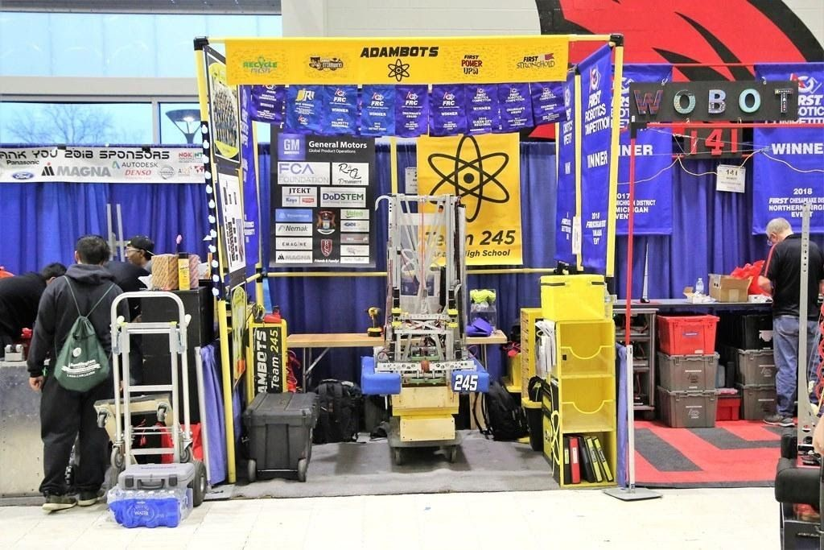

The imagery sub-team is an integral part of our marketing, allowing us to become more recognizable and memorable within the FIRST​ community. We strive to be cohesive in every aspect, from team shirts, documentation and presentation materials to the website and social media channels, as well as our competition pit displays and the robot’s graphics. We also give out marketing items at competitions, such as our renowned ducks, team buttons, and LBGTQ+ brochures and business cards.

**Newsletter**

We distribute a monthly electronic newsletter to all our partners including sponsors, school administration, teachers, politicians, community leaders, parents, students, and mentors. Subscribers sign up to receive the newsletter on the team website, and an online service called MailChimp is used to email it to subscribers. This newsletter enables our partners to keep up to date with team activities and plans. It includes information about competitions, outreach, team recognition and awards, a team wish list identifying material and support needs and recognizes our sponsors.

**Online Presence**

We operate various social media accounts on Facebook (789 likes), Instagram (1,101 followers), Twitter (1,662 followers), and YouTube (133 subscribers). Using these tools, sponsor, competition, and community outreach information, as well as team news, is communicated to families, classmates, friends, and members of the community. Our online presence helps build interest in FIRST​ and enables us to communicate with other teams across the globe.

***FIRST*​ Support**

We get our name out to the global ​FIRST​ community by supporting teams. This includes mentoring and collaborating with teams through video calls, giving support to the Japanese teams, and publishing resources.

# 7.0 Financial Plan

We focus on long-term financial sustainability to ensure success. Financial support comes from three different sources: partners (sponsors), team member fees and contributions and our Art & Apples Festival parking lot business. We have contingencies in place, such as leaving “seed” money for the following year, so that we will still be in a viable financial condition if we lose a sponsor, fundraiser or have some other event that results in a loss of funding.

## 7.1 Partners

Partners are the primary method in which we receive financial support. Our goal is to obtain enough funding to cover the costs of both FIRST​ registration fees and robot parts. Currently, we have ten partners and receive donations from several friends and family of team members. We also strive to obtain at least one new partner each year and keep all partners from the previous year. This is accomplished through partner thank you notes and letters and recognition, our monthly electronic newsletter, and our annual “Meet the AdamBots” open house.

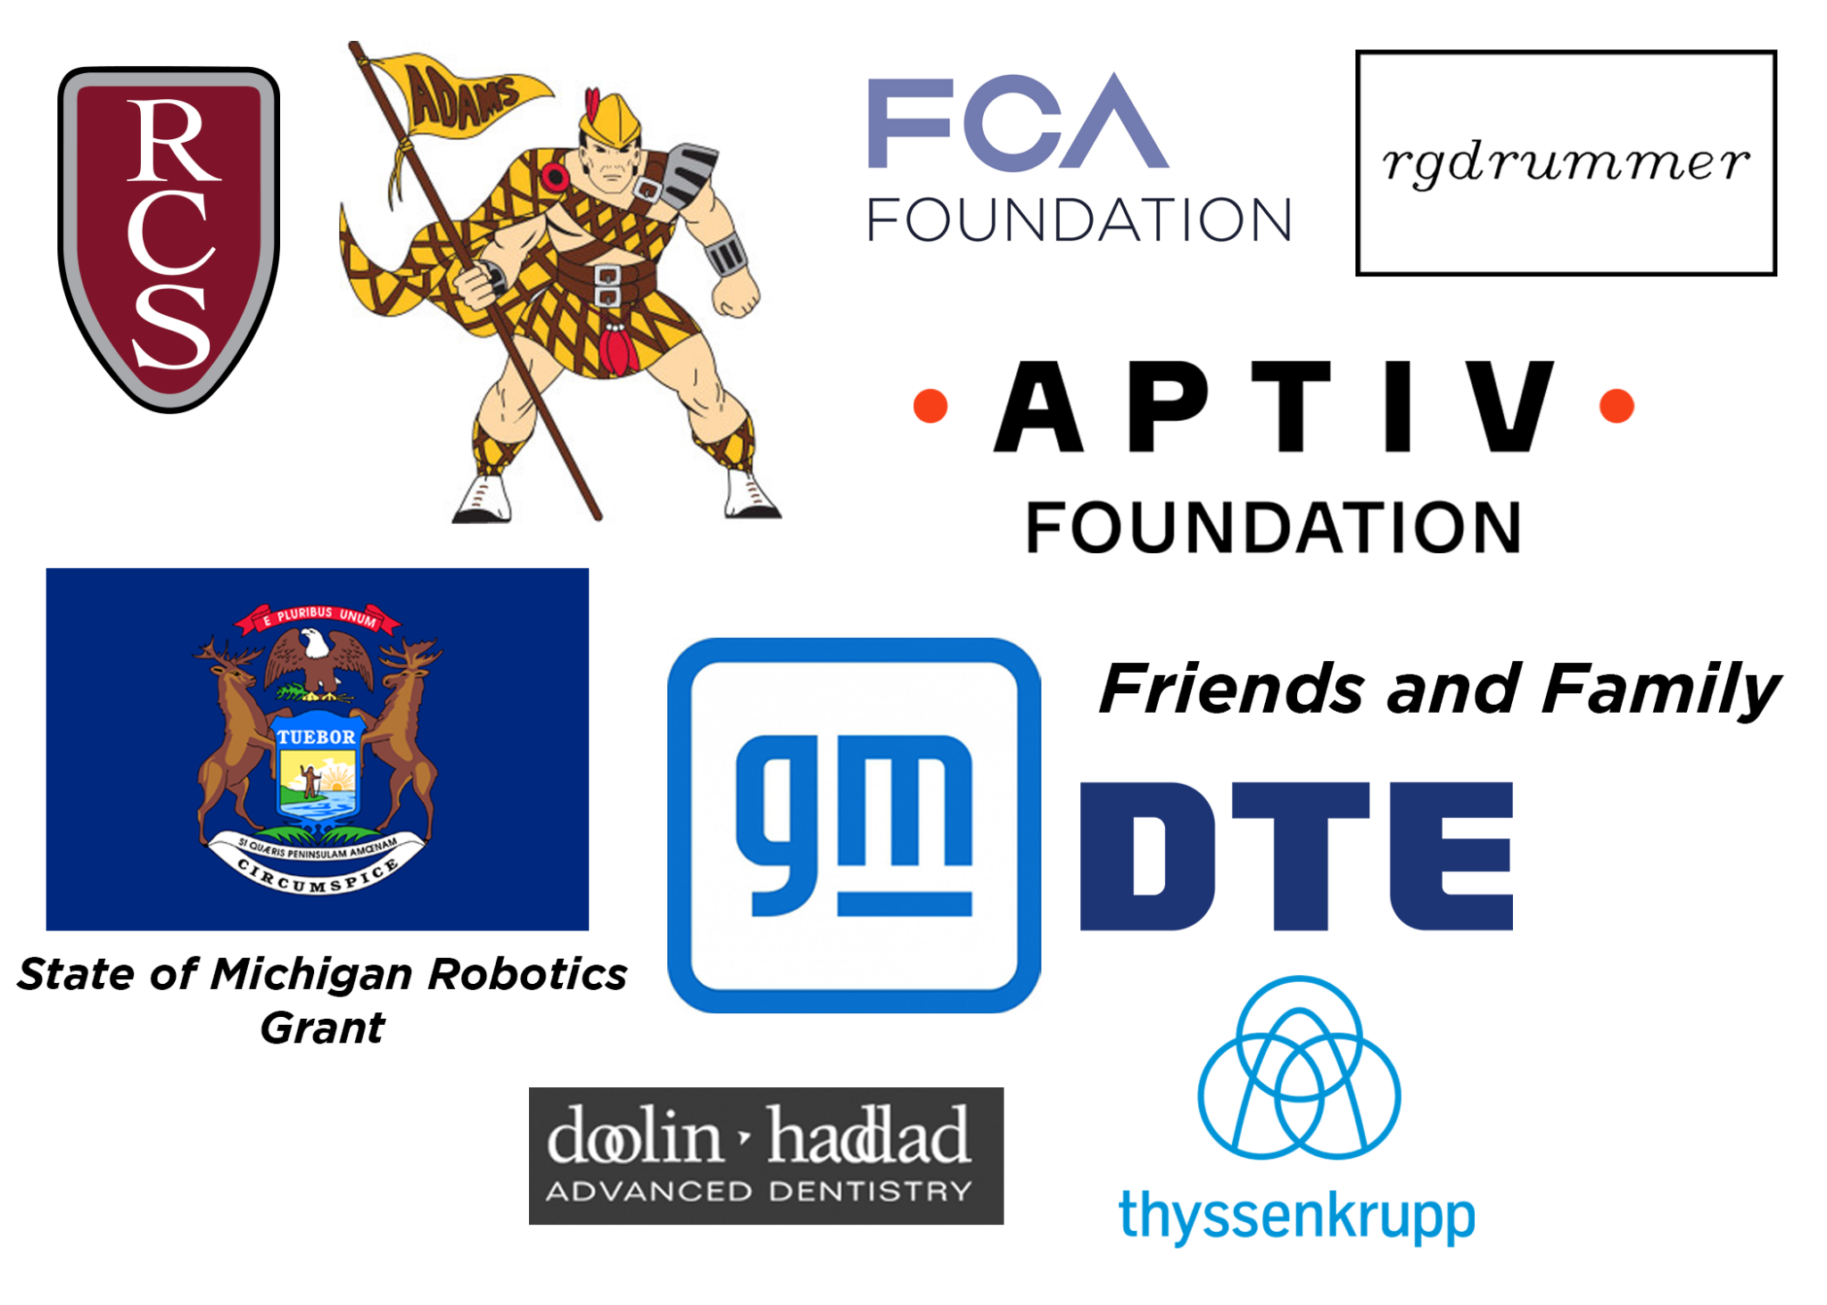

## 7.2 Member Contribution

Students and mentors also contribute financially. Students pay annual registration fees which help pay for team uniforms and transportation to competitions. This includes bus transportation to Michigan district and state championship, out-of-state regional, FIRST​ Championship and off-season competitions. When we travel out of the area for events, students and mentors usually pay a portion of the cost of travel and lodging.

## 7.3 Parking Lot Business

Each September, AdamBots students, parents, and mentors operate a profitable parking lot business during a three-day arts festival, Art & Apples Festival, which is held in the local Rochester Park. This festival is a well-known tradition within the community and attracts thousands of people from a wide area. All funds raised go towards team expenses.

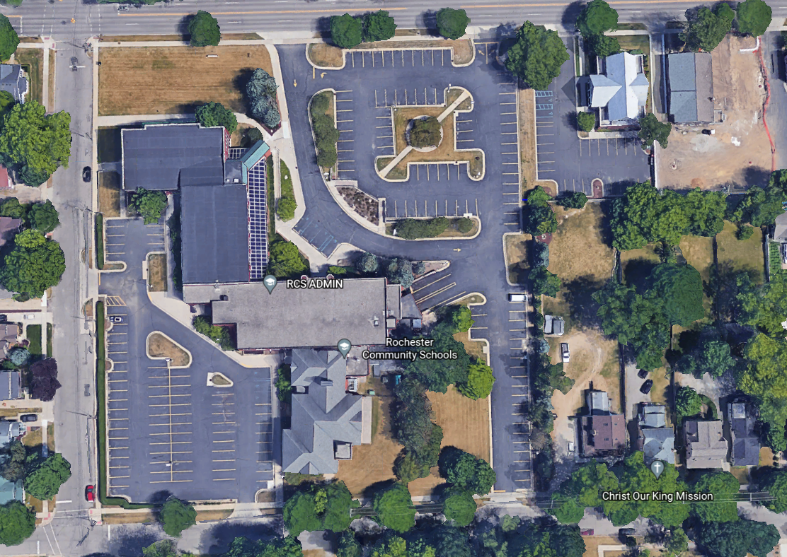

Front Lower Lot

Dental Lot

Back Lower Lot and Lower Lot Exit

Entrance to Back Upper Lot

Back Upper Lot Exit

Entrance to Lower Lot

## 7.4 2022 Financial Graphic

## ($76,000 Budget assuming going to World Championship)



***Uses of Funds:***

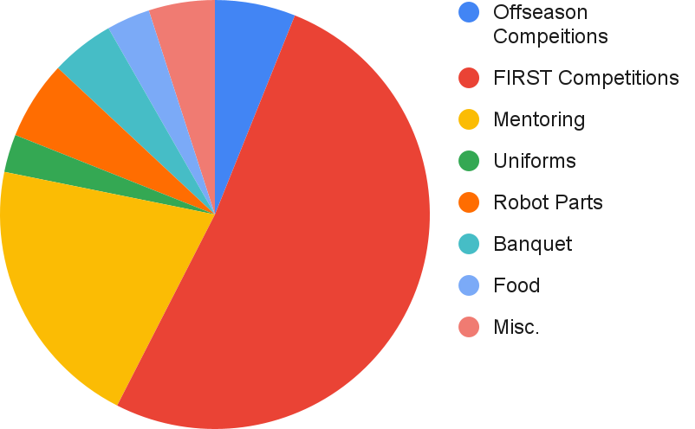

***Sources of Funds:***

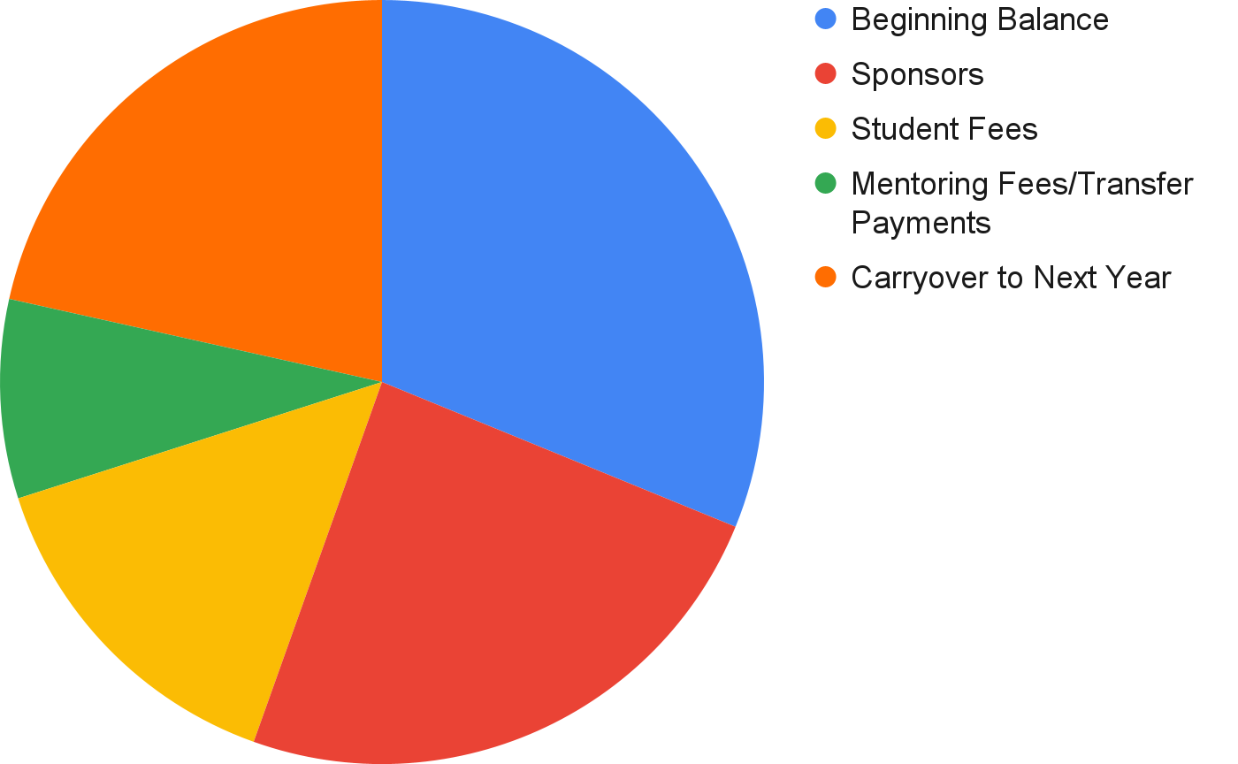

## 7.5 Financial Contingency Plan

The AdamBots created a financial contingency plan to prioritize spending in case of budget cuts.

|  |  |  |
| --- | --- | --- |
| **Priority** | **Tentative Cost** | **Budget Item** |
| **1** | $5,000 | Registration for two local district events |
| $4,000 | Supplies for one competition robot |
| $2,000 | Basic team spirit wear |
| $4,000 | State Championship registration |
| $5,000 | *FIRST* ​World Championship registration |
| **2** | $10,000 | Support for FLL-E, FLL-C, and FTC Teams |
| $500 | Registration for a third district event |
| **4** | $12,000 | Third event as travel competition |
| $1,000 | Registration for local offseason events |
| $5,000 | Registration and travel for Indiana Robotics Invitational |
| $3,000 | Expansion of equipment (tools, computers, cameras, etc.) |
| **5** | $1,500 | Registration and supplies for OCCRA |
| $3,500 | Banquet celebration |
| $5,000 | Additional team spirit wear |
| $1,000 | Pit marketing materials |

# 8.0 Strategic Plan

## 8.1 Strategic Planning Process

The AdamBots Strategic Plan was created in 2014. Students and mentors work together to review and update it two times per year (spring post-season and fall pre-season). The process begins with our mission to inspire growth and appreciation of STEM, business, and career skills. To accomplish it, we’ve broken it into five key team strategies. Then, we analyze our team internally (strengths and weaknesses) and externally (opportunities and threats) to create a list of actionable items. We then review the list in the context of each key team strategy to structure conversations on our plans for the next few years.

## 8.2 Team Strategies

The AdamBots have a Strategic Plan that supports the team’s mission statement and is used to make team improvements, manage risk, and enhance team sustainability. The Strategic Plan identifies five long-term team strategies with supporting action plans.

|  |
| --- |
| **AdamBots Team Strategies** |
| **Grow a Model Team** |
| **Learn and Continuously Improve by Building a Successful Robot** |
| **Develop Strong Team Leadership** |
| **Develop Excellent Team Financing and Partner Relationships** |
| **Develop the** ​***FIRST*** ​**Community** |

## 8.3 SWOT Analysis

The AdamBots completed a SWOT analysis for all five strategies to identify team strengths, weaknesses, opportunities, and threats. The composite SWOT analysis chart below combines the SWOT analysis for all five strategies.

|  |  |  |  |
| --- | --- | --- | --- |
|  | **Composite SWOT Analysis for all AdamBots Team Strategies** | | |
|  | **Strengths** |  | **Weaknesses** |
|  | 1. Large, skilled, accessible body of long-term mentors 2. Large body of students organized in strong, sustainable structure 3. Students and mentors with knowledge and interest in wide variety of fields including engineering and business 4. Strong sponsor and financial partnerships 5. Succession planning from youth STEM programs and sub-team structure 6. Strong support from school principal and staff 7. Development of real-world skills such as   communication, collaboration, and career preparedness |  | 1. Lack of succession planning for specific mentor roles 2. No teacher mentors 3. Fall CAD and programming training programs 4. COVID impact on skills development for past two years |
|  | **Opportunities** |  | **Threats** |
| 1.  2.  3.  4.  5.  6. | 1. Focus on developing student skills 2. School involvement 3. Dedicated offseason group for developing new engineering prototypes, skills, and techniques 4. Improve drive train by incorporating swerve drive 5. Learning from industry experience 6. Growing school administration support | 1.  2.  3.  4.  5. | 1. Loss of mentors in key roles 2. Loss of financial support 3. Loss of build space 4. Loss of school district support 5. Loss of robot transportation |

## 8.4 Action Plans and Risk Mitigation

|  |  |  |
| --- | --- | --- |
| **AdamBots Team Strategy: Grow a Model Team** | |  |
| **Action Plan** | **Responsible** | **Estimated**  **Completion** |
| Maintain past efforts to grow a model team | Business Planning  Sub-team | Continuous |
| Develop build space, including expansion, space utilization, and equipment | Lead mentors | Continuous |
| RISK MITIGATION:​ Gain at least one new mentor every year | Financial Manager | Annually  by end of year |
| Retain mentors for 3+ years | Lead mentors | Continuous |

**Grow a Model Team**

We want to continually develop ourselves to be the kind of team that we believe all teams should strive to be. This includes upholding FIRST​ ​’s mission, solving our community’s problems, being respectful to all people, maintaining strong student involvement, and continuously improving and sustaining.

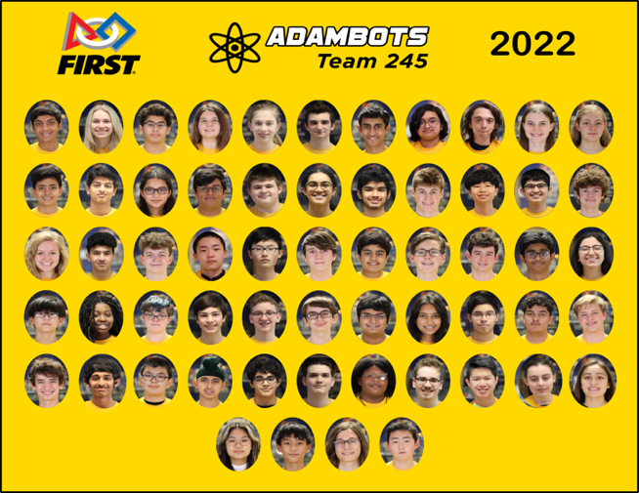

|  |  |  |
| --- | --- | --- |
| **AdamBots Team Strategy: Learn and Continuously Improve By Building a Successful**  **Robot** | | |
| **Action Plan** | **Responsible** | **Estimated**  **Completion** |
| Maintain past efforts to learn and continuously improve | Business Planning  Sub-team | Continuous |
| Invite experts to share knowledge with the team | Sub-team student leaders and mentors | Continuous |

**Learn and Continuously Improve By Building a Successful Robot**

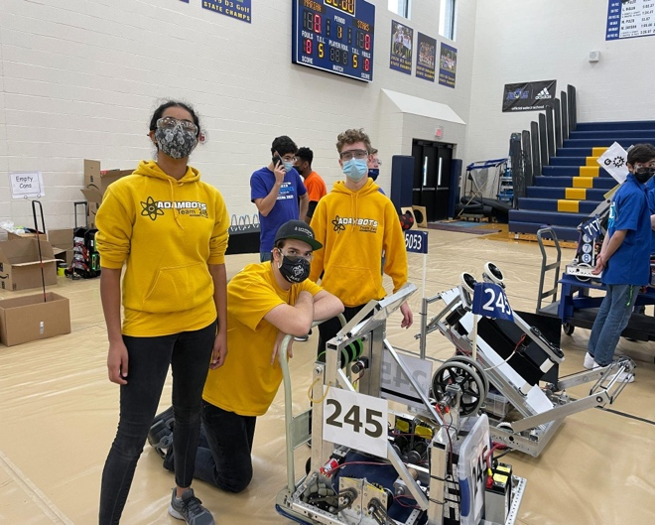We strive to teach students STEM skills, leadership, project management, and collaboration. We strive for our students to lead our process for building the best robot we can each year and by expanding our teaching and engineering capabilities.

|  |  |  |  |  |
| --- | --- | --- | --- | --- |
| **AdamBots Team Strategy: Develop Strong Team Leadership** | | | | |
| **Action Plan** | | | **Responsible** | **Estimated**  **Completion** |
| Maintain past efforts to develop strong team leadership | | | Business Planning  Sub-team | Continuous |
| Continue new mentor training “Mentor to Mentor” | | | Experienced mentors | Continuous |
|  | RISK MITIGATION:​ | Maintain and monitor sub-team depth | Business Planning  Sub-team | Annually by June  17th |
| charts |

**Develop Strong Team Leadership**

We strive to develop mentors and student leaders who can manage teams and bring the team as a whole forward.

|  |  |  |  |  |
| --- | --- | --- | --- | --- |
| **AdamBots Team Strategy: Develop Excellent Team Financing and Sponsor**  **Relationships** | | | | |
| **Action Plan** | | | **Responsible** | **Estimated**  **Completion** |
| Maintain past efforts to develop team financing and partner relationships | | | Business Planning  and Public Relations Sub-teams | Continuous |
|  | RISK MITIGATION:​ | Gain at least one new sponsor every | Financial Manager | Annually by end of year |
| year |

**Develop Excellent Team Financing and Sponsor Relationships**

A solid financial plan ensures we can support achieving our mission.

|  |  |  |
| --- | --- | --- |
| **AdamBots Team Strategy: Develop the** ​***FIRST***​ **Community** | | |
| **Action Plan** | **Responsible** | **Estimated**  **Completion** |
| Start a ​*FIRST*​ team at every K-12 school within Rochester  Community Schools | Rochester United Robotics leadership | September 2023 |
| Work with ​*FIRST* ​in Michigan to support a rookie or small FRC team each year | Team Manager | Annually in September |
| Share information on ways students can get involved in the global FRC community | Chairman’s  Sub-team | Annually in  October |

**Develop the ​FIRST​ Community**

We believe that by starting ​FIRST​ teams and helping existing ​FIRST​ teams, we can expand our ability to foster growth and appreciation of STEM, business, and career skills in students.

# 9.0 Measuring Success

## 9.1 Key Performance Indicators

The AdamBots implemented a plan for key performance indicators (KPIs). The purpose is to measure changes in overall team success by examining several important factors. We determined our KPIs by examining our core values and mission statement. Measurements are taken through surveys, collected team statistics and competition performance. Our KPIs are:

|  |  |
| --- | --- |
| **Indicator** | **Measurement Method** |
| Competition Performance | Elo rating |
| Student STEM Interest | Participation in STEM clubs at Adams High School |
| Alumni STEM Interest | Percent of graduates that move on to STEM fields |
| Student skills | Annual survey |
| Team Environment / Core Values | Annual survey |

## 9.2 Implementation

Twice a year, the team meets to review the Strategic Plan. Data from our KPIs helps to facilitate discussion and back up modifications with evidence. The Business Planning Sub-team and mentors meet to analyze the data before these meetings.