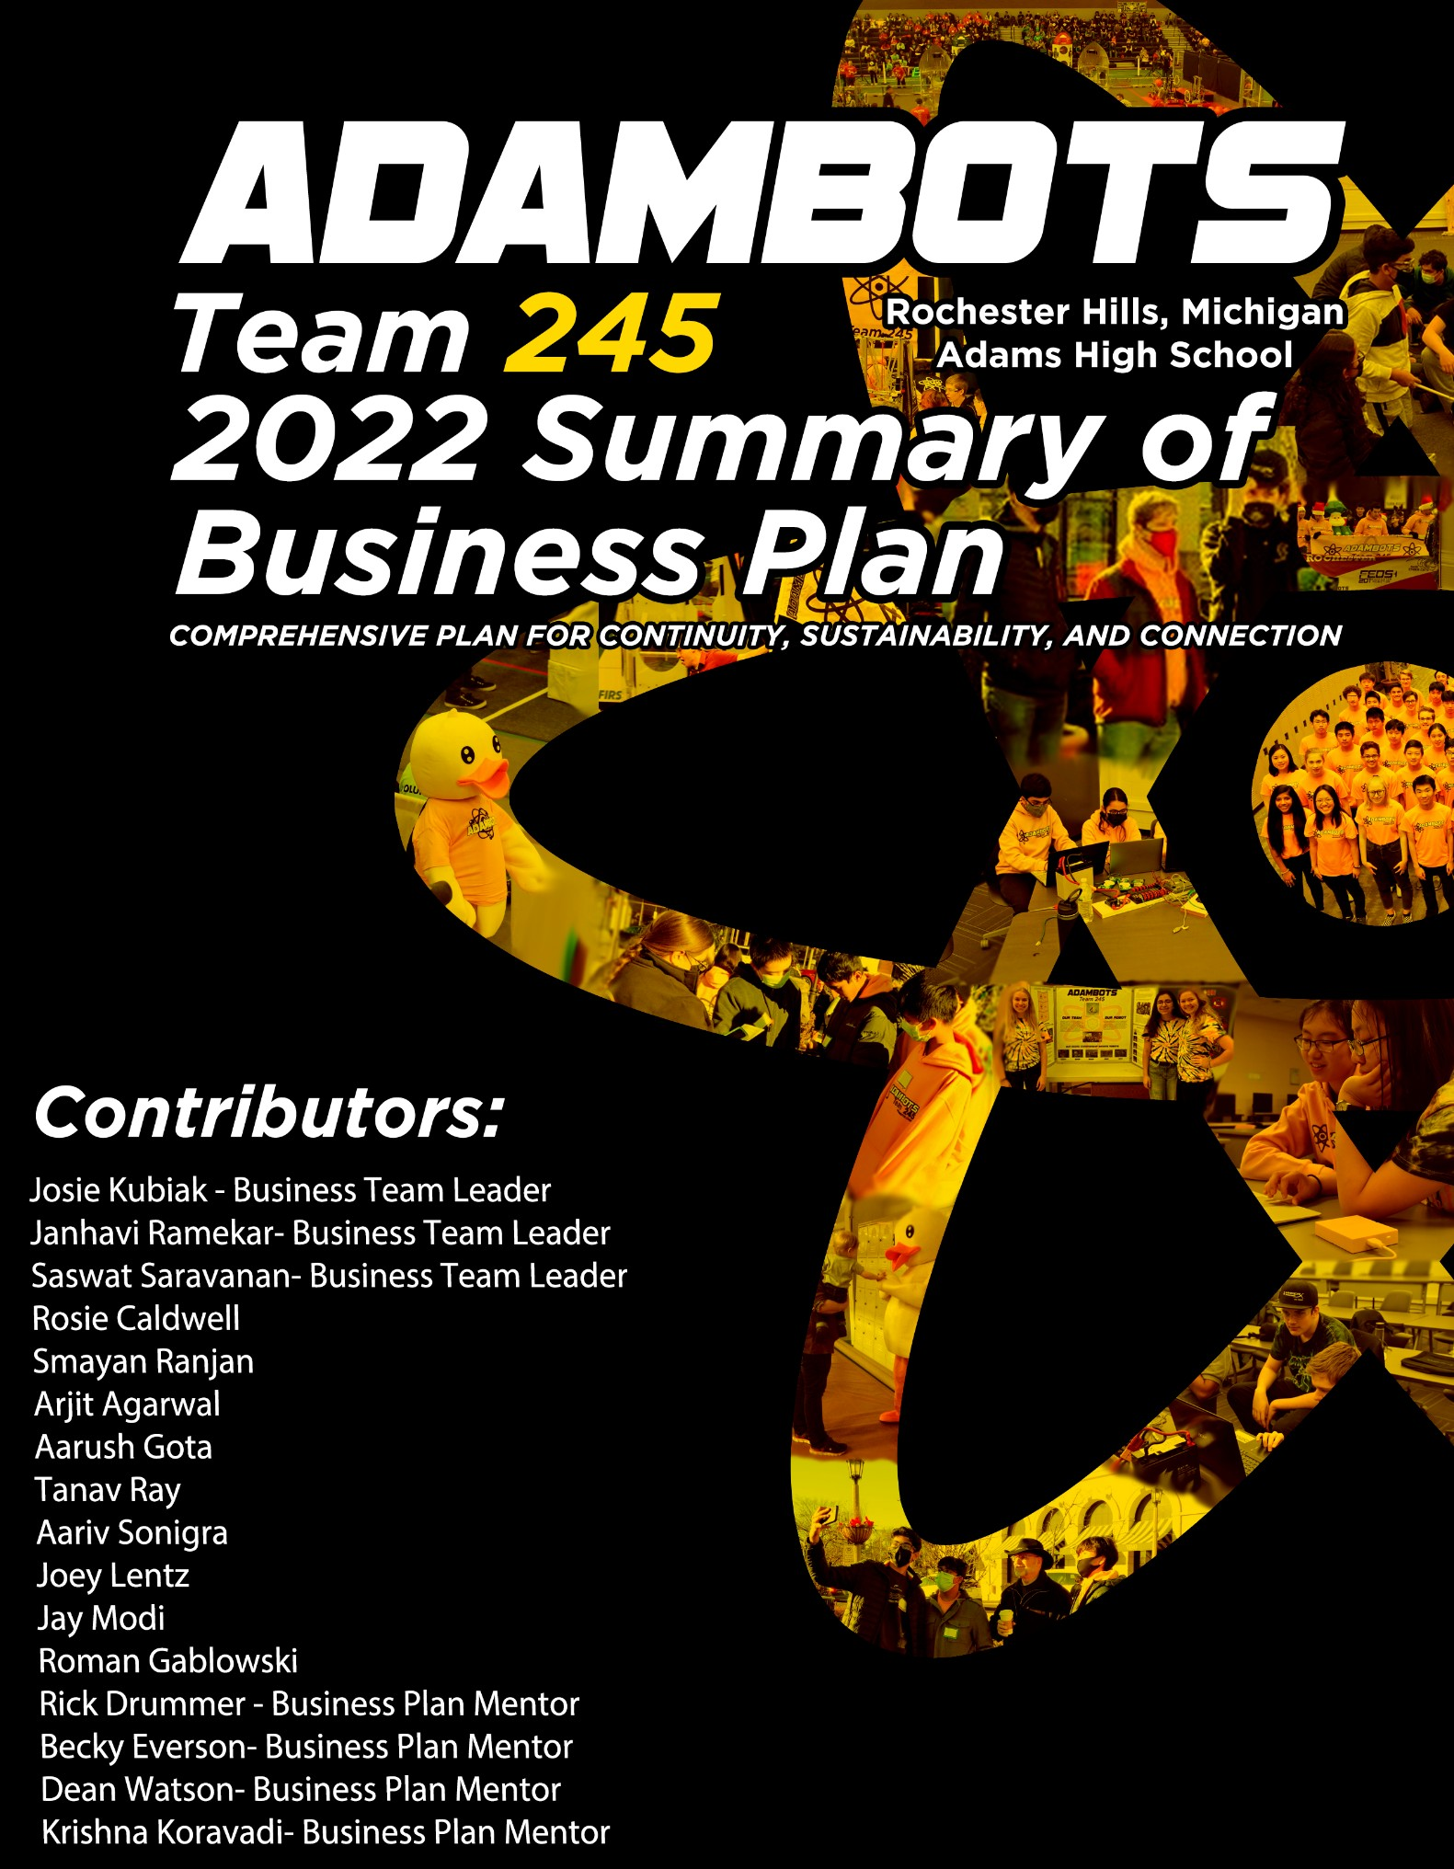

# A yellow and black logo Description automatically generated with low confidenceMission Statement

*“To provide an inspiring learning environment that fosters growth and appreciation of STEM and business knowledge, and to teach students skills vital to success in the real world through a strong relationship between students, mentors, and sponsors.”*

# Team Core Values

At the nucleus of our mission, student and mentor team members collaborate to inspire interest, knowledge and application of STEM, business, and leadership skills. FIRST values such as Gracious Professionalism™ and Coopertition™ serve to bond our members-- students and mentors alike-- and provide a focus for all that we do. Orbiting the nucleus are our Core Values which further energize us to sustainable team success and contribute to the goal of spreading the word of FIRST. The AdamBots Core Values are: Gracious Professionalism, Respect, Teamwork, Innovation and Creativity, Fun, Commitment, Cooperation and Communication

# Team History and Growth

Based at Rochester Adams High School in Rochester Hills, Michigan, the AdamBots began in 1999 with a small team of ten. We have grown steadily and today have 58 students and 25 mentors. We build our robots and run our business teams at Adams using a connected set of rooms including the build room, CAD room, electrical room, our dedicated practice field, storage room, and two classrooms. The AdamBots are heavily involved in the local and global STEM communities, including supporting FIRST at all levels. We have many sponsors, including corporate, government and friends and family that together fund almost half of our team expenses.

We have a strong system for preparing new students for the challenges of the FIRST season. We start by teaching the elementary and middle schoolers in our 2 FTC teams and 20 FLL teams. This prepares them to eventually join the AdamBots. All our new students participate in rookie workshops to get exposure to all aspects of the team, plus to learn required safety skills. They then attend our Core Values Boot Camp to learn about our culture as they have fun in team-building activities.

To manage mentor turnover, we’ve been increasing succession planning for key roles. Our risk analysis tells us that we have a few key mentors that have been with the team for over 20 years, and it is important to have a succession plan for when they eventually leave. We have started the documentation of these key roles and started training others on what they do.

Amongst engineering sub-teams, we pair up mentors of varying experience to ensure we have adult leadership for years to come. We’ve developed a diverse body of mentors, with 12 mentors who joined in the past four years and 8 mentors with more than ten years of experience. Although many of our mentors join to support their children, they often stick around after graduation; 19 of our 25 mentors have no children on the team.

# Organizational Structure

## Sub-team Structure

The AdamBots are made up of 9 engineering sub-teams and 6 business sub-teams. These sub-teams are overseen by our engineering project management group, which looks out for overarching team goals, deadlines, and inter-sub-team communications. A chart showing these sub-teams can be found in Appendix A. Our sub-teams are structured to ensure each student gets the most they can out of our team. Each sub-team has its own specific responsibilities which helps us to engage all our students and mentors and allows students to choose which aspects of the team they want to focus their time on. Each sub-team has at least one student leader and one mentor so we can develop leadership skills while learning from professionals, aided by our 2:1 student to mentor ratio.

## Planning for Growth

With so many students already on our team, growth to us means deepening the impact on our students, rather than simply gaining more students. As part of the Skills Approach to Sub-teams, we’re developing new training methods to expand student knowledge.

Despite our large numbers, our team is rapidly growing and enthusiasm, and we expect it to continue to in the future. One cause of this is the expansion of our K-12 STEM programs. This year, the AdamBots are mentoring 19 FTC, 47 FLL-C, and 58 FLL-E students.

Risk Analysis

The AdamBots Strategic Plan was created in 2014. Students and mentors work together to review and update it annually. The process begins with our mission to inspire growth and appreciation of STEM, business, and career skills. To accomplish it, we’ve broken it into five key team strategies. Then, we analyze our team internally (strengths and weaknesses) and externally (opportunities and threats) to create a list of actionable items. We then review the list in the context of each key team strategy to structure conversations on our plans for the next few years.

Our Strategic Plan supports the team’s mission statement and is used to make team improvements, manage risk, and enhance team sustainability. The Strategic Plan identifies five long-term team strategies with supporting action plans. Our Key Team Strategies are: Grow a Model Team, Learn and Continuously Improve by Building a Successful Robot, Develop Strong Team Leadership, Develop Excellent Team Financing and Partner Relationships, and Develop the FIRST Community. For example, to respond to the threat “Loss of financial support,” we have an Action

Plan of “Gain at least one new sponsor each year” as part of the Key Team Strategy “Develop Excellent Financial Relationships.” To ensure our Action Plans are successful at achieving our mission, we measure success through several Key Performance Indicators.

# Marketing and Relationships

## Online

* *Website:* [*www.adambots.com*](http://www.adambots.com/) *with 60,000+ unique visitors since 2005*
* *Facebook:*
* *Twitter: @AdamBots*
* *Instagram: @adambots245*
* *YouTube: AdamBots Team 245*

## Local Community

* *Meet the AdamBots open house: family, school, sponsors, politicians (pandemic dependent)*
* *Rochester Hometown Christmas Parade with Teams 201 and 5436: 65,000+ annual viewers (canceled this year)*
* *Relay for Life: over $100,000 raised*
* *Hunger Walk*
* *Treats for Troops*
* *Collected Board games for the Rochester Neighborhood House.*
* *Coats for the Cold*
* *Halloween Hoot*
* *Holiday cards for the Older Persons Commission*
* *Scare Away Hunger (pandemic dependent)*
* *Toys for Tots*

# Financials

## School

* *Demos at sporting events and local elementary schools*
* *Participated in the school diversity equity and inclusion board meeting*
* *Mentors on Career and Technical Education Advisory Committee*
* *Students and parents on PTSA STEAM Committee*
* *FTC OCCRA League Qualifiers fall competition hosted at Adams*
* *Front entrance trophy case*
* *New Robotics Room for practice field*

## FIRST Community

* *Weekly video calls with 11 other teams from Michigan and Mexico*
* *Continually support all three Japanese teams*
* *Published resources on business planning*
* *Showing support towards the LGBTQ+ community*
* *Business Planning Workshop at Kettering University*
* *Lambots’ FIRST Robotics Fest Presentation on Business Plan and Team Organization*

Most this year’s $76,000 sources of funds come from corporate sponsorships and grants, followed by student fees and by team fundraising businesses. To remain partially self-funded, we run a parking lot business at the local art festival, which accounts for about $7,000 annually. Additionally, last year we started a card game business called Robots: Build and Clash to learn real-world business skills first-hand.

Our budgeting process starts with our history of expenditure. For example, we allocate $5,500 for the Kettering 1st District Event, including registration and food. We then update our budget spreadsheet as actual values come in, like the number of students attending and transportation costs. When planning our budget, we assume the largest foreseeable expenditure, which would be attending a travel event, the District Championship, and the FIRST Championship. This way, we’re never scrambling to make up funds for a potential expense like qualifying for the next level of competition. Each year, we leave at least $10,000 for the following year to ensure we can compete in case of total loss of funding. This year, we started with $40,000 in surplus, allowing us to reduce student fees.

To develop relationships with our sponsors, we recognize our sponsors by displaying their logos on our robot and on a banner in our pit. We invite current and potential sponsors to Meet the AdamBots, and this year, we made a video to thank them for their continued support. We gain at least one financial sponsor each year. We’ve had a close relationship with General Motors for 15 years. We demonstrate our robot at their facilities 1-3 times a year and support other sponsored teams at their request. GM recognized our team with the GM Team of the Year Award in 2011 and our mentors with the Tom Stephens Award in 2016 and 2018.

Learn more at www.admabots.com

# Appendix A: Team Summary

This year, our team gained 30 new students, expanding to 58 students. Among these, we have:

1 8th grader,

31 freshmen,

7 sophomores,

8 juniors

11 seniors.

We have 25 mentors on the team, with over 224 years of total experience. 19 of our mentors no longer have children on the team, and our best explanation is that they have just as much fun as the students!

# Appendix B: Finances

# ($76,000 assuming going to World Championship)

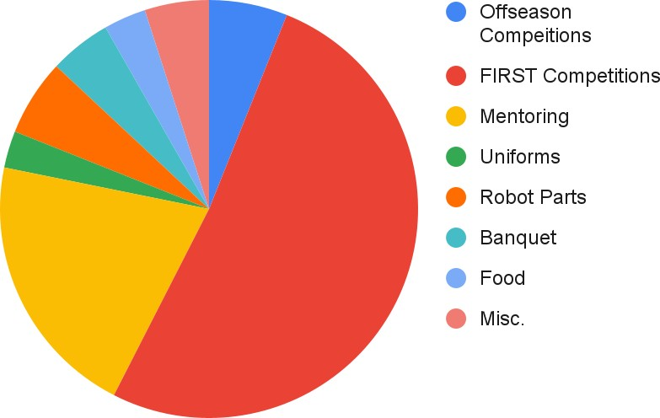***Uses of Funds:***

***Sources of Funds:***

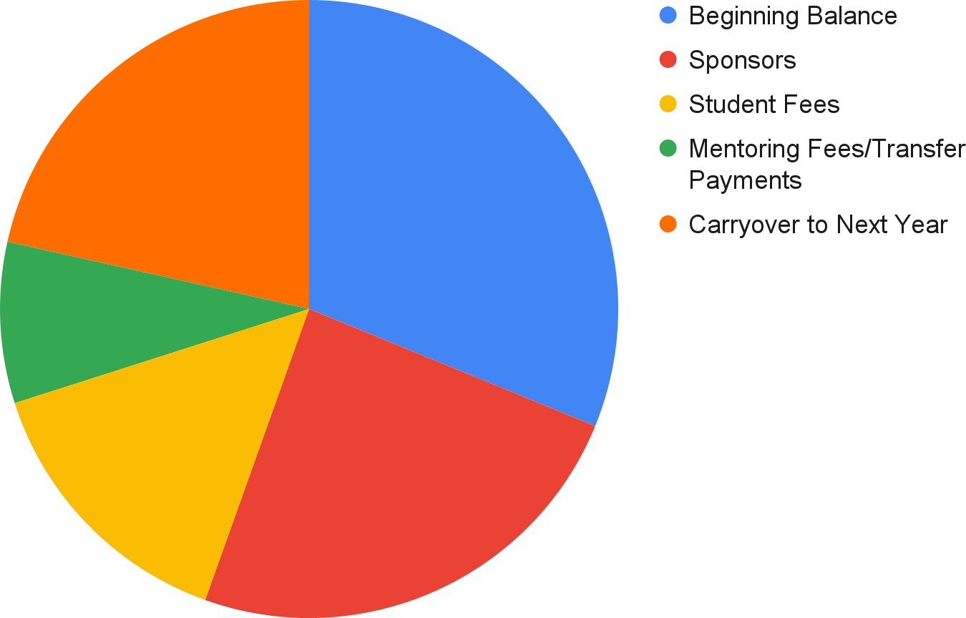

## Sponsors (Financial Support)

General Motors, APTIV Foundation, R&G Drummer, DTE Energy, FCA Foundation, State of Michigan Robotics Grant, Thyssenkrupp, Rochester Advanced Dentistry

## Partners (Non-Financial Support)

Rochester Community Schools, Rochester Adams High School, Friends and Family

***Appendix C: Risk Analysis***

|  |
| --- |
| **AdamBots Team Strategies** |
| **Grow a Model Team** |
| **Learn and Continuously Improve by Building a Successful Robot** |
| **Develop Strong Team Leadership** |
| **Develop Excellent Team Financing and Partner Relationships** |
| **Develop the *FIRST* Community** |

